**EVENT MANAGEMENT SYSTEM**

**Simple Page-Wise Working Explanation**

**1️⃣ Dashboard Page**

**✅ How It Works:**

The Dashboard is the main overview page of the system.

It automatically displays:

* Total number of events
* Completed events
* Upcoming events
* Total revenue
* Quick statistics summary

The data is fetched from the EventService and calculated dynamically.

**🎯 Purpose:**

* Gives admin a quick summary of business performance
* Shows system activity at a glance
* Helps in decision making

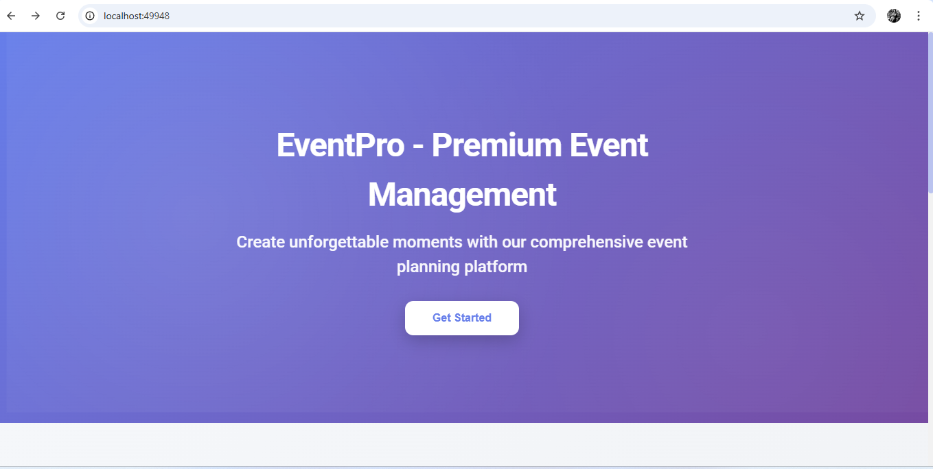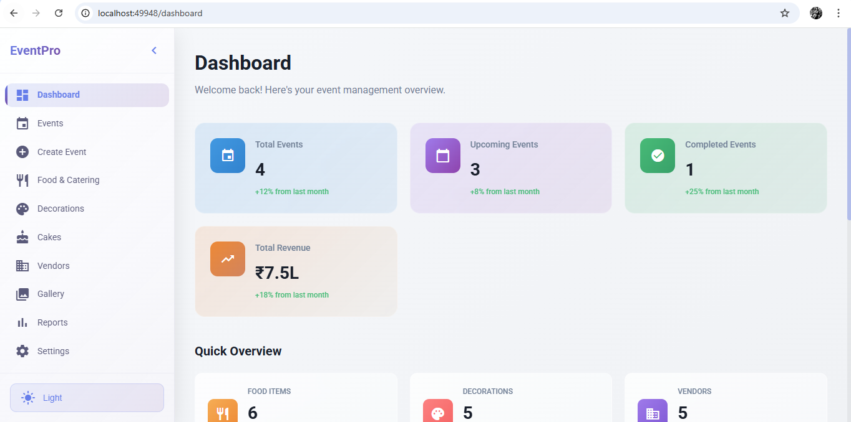

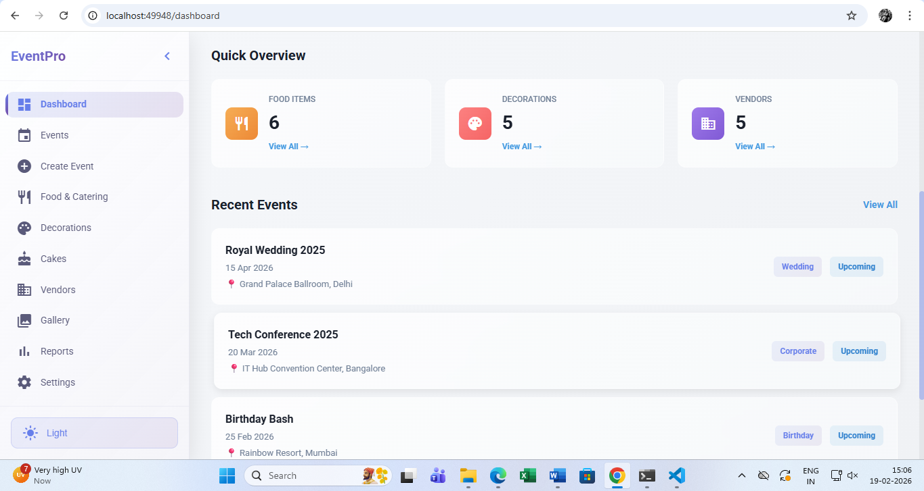

**2️⃣ Events Page**

**✅ How It Works:**

This page displays all created events in a card or table format.

Each event shows:

* Event name
* Event type (Wedding, Corporate, Birthday, etc.)
* Date
* Budget
* Status (Upcoming / Completed / Cancelled)
* Assigned client

User can:

* Edit event
* Delete event
* View full details

The event data is stored in memory (or local storage if implemented) using EventService.

**🎯 Purpose:**

* Manage all events in one place
* Track event progress
* Maintain event records

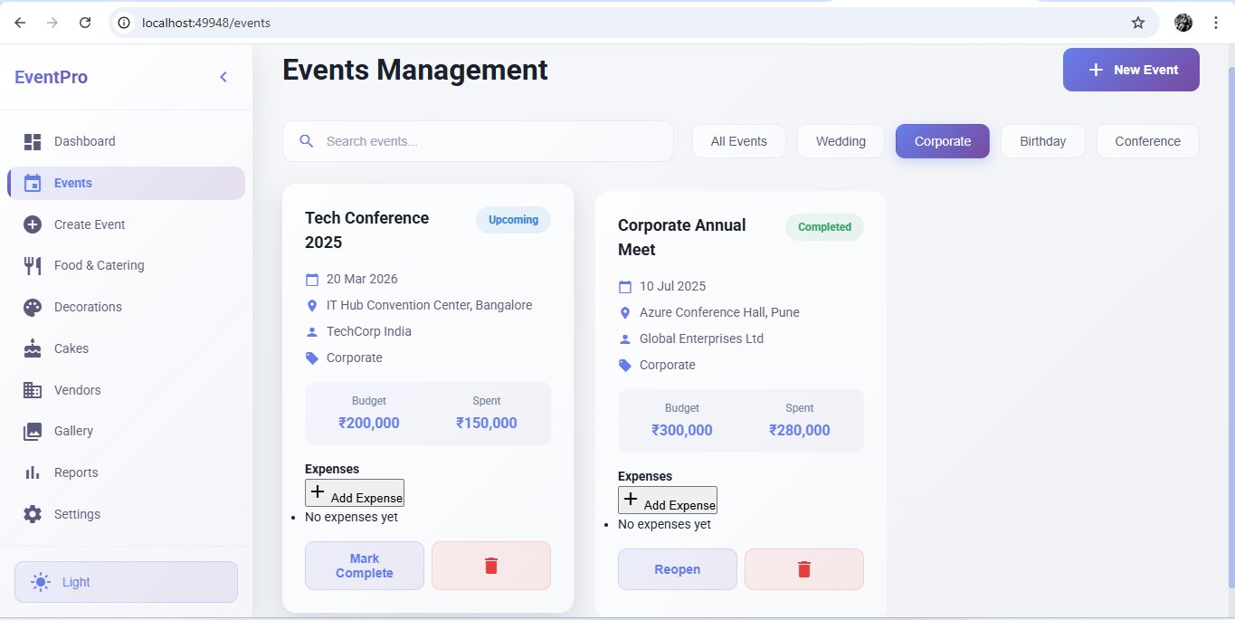

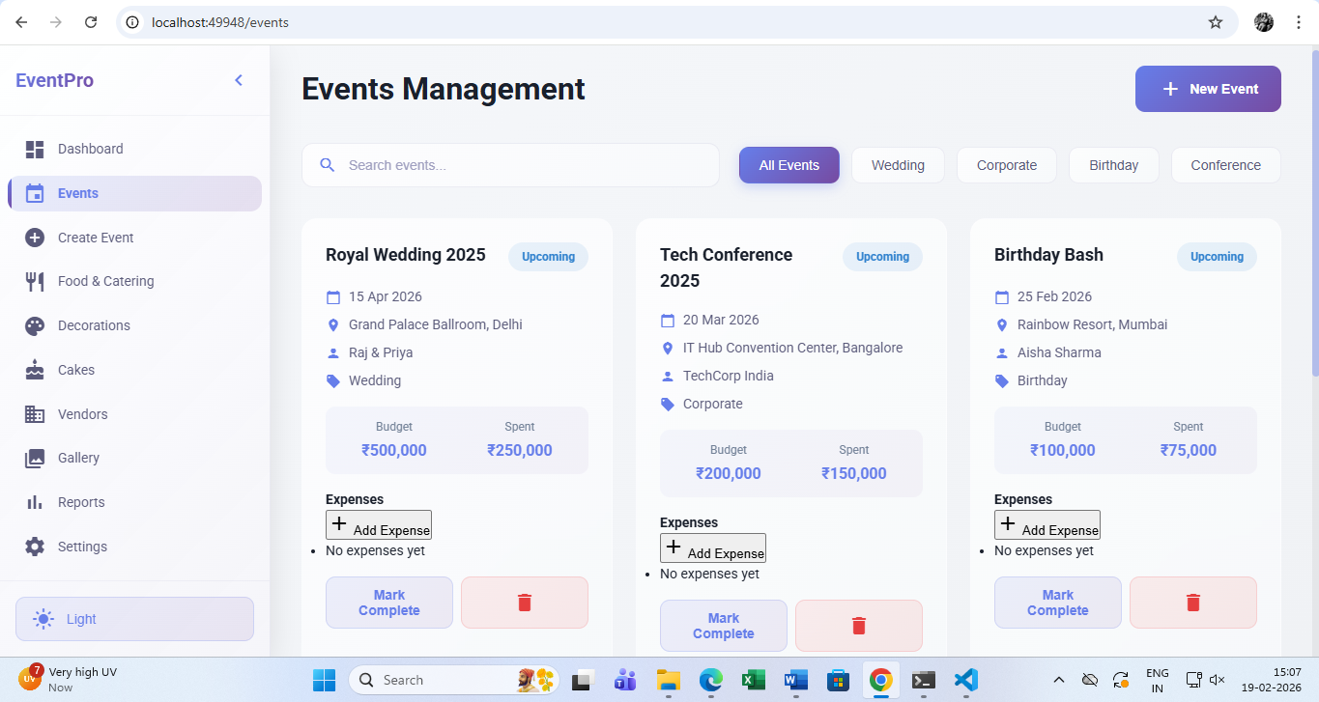

**3️⃣ Create Event Page**

**✅ How It Works:**

This page contains a form where user can enter:

* Event Name
* Event Date
* Location
* Budget
* Event Type
* Client Name
* Vendor Assignment

When user clicks "Create Event":

* Form data is validated
* Event is saved into the service
* Dashboard and Events page automatically update

**🎯 Purpose:**

* Add new events into the system
* Start event planning workflow

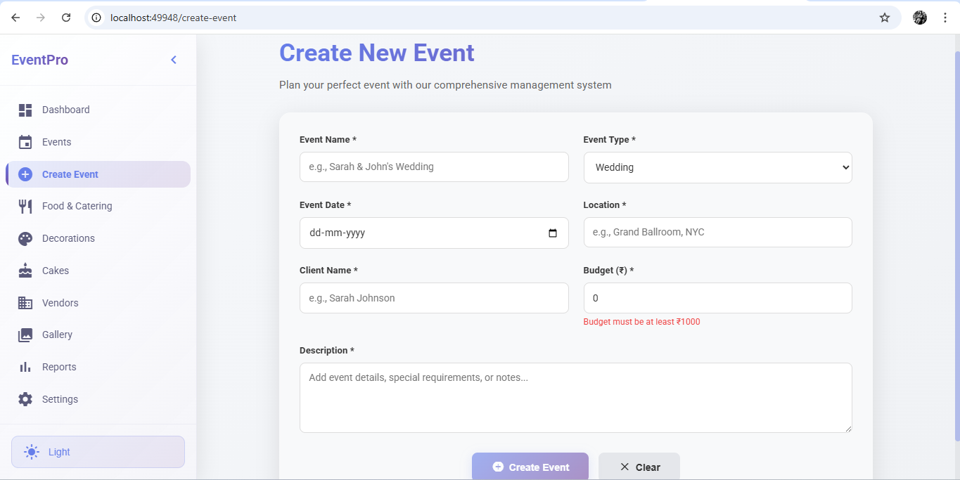

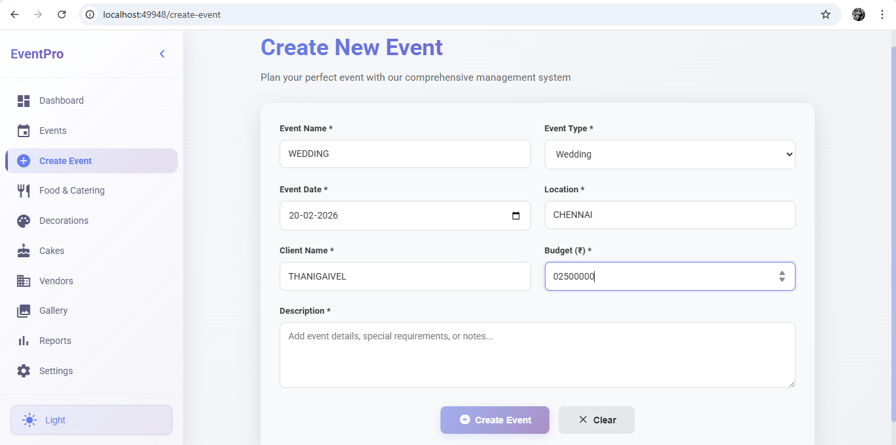

**Food & Catering Page**

**✅ How It Works:**

This page displays food items grouped into categories:

* Starters
* Main Course
* Desserts
* Beverages

Each item includes:

* Image
* Price
* Veg/Non-Veg label

User can:

* Select multiple food items
* Add them to an event
* Automatically calculate total catering cost

**🎯 Purpose:**

* Customize menu per event
* Calculate catering budget easily

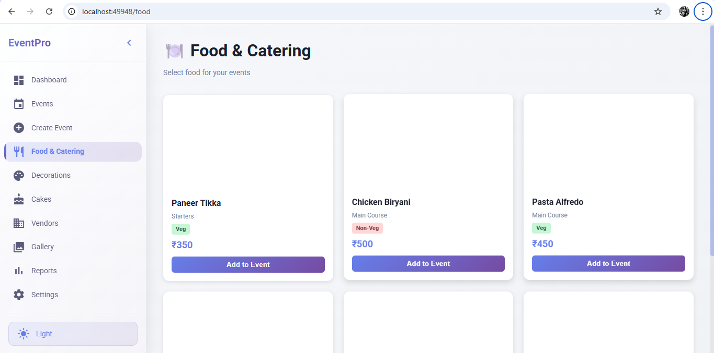

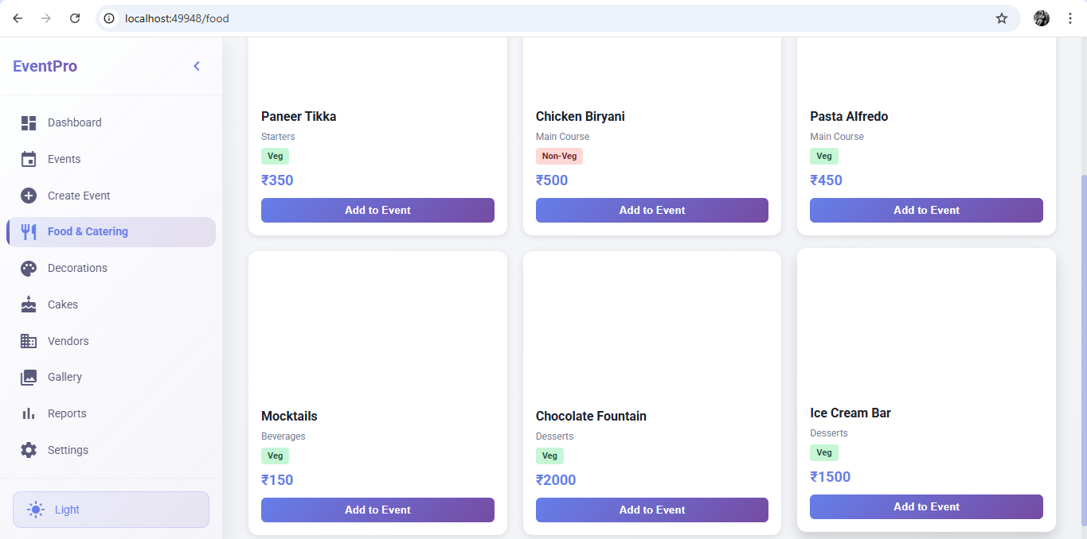

**Stage Decorations Page**

**✅ How It Works:**

This page shows different decoration themes with images.

Each decoration includes:

* Preview image
* Description
* Price

User can:

* Select one decoration theme
* Attach it to an event

Selected theme cost is added to event budget.

**🎯 Purpose:**

* Choose event theme visually
* Simplify decoration planning

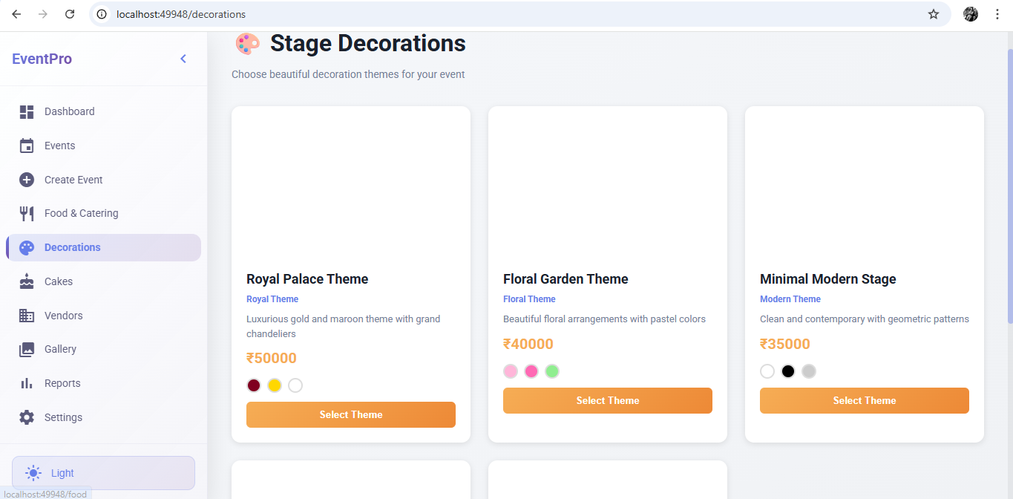

**Cake Models Page**

**✅ How It Works:**

This page displays cake designs with images.

Each cake includes:

* Cake image
* Name
* Price per kg
* Weight options

User can:

* Choose cake model
* Select weight
* Add to event

Total cake cost is calculated automatically.

**🎯 Purpose:**

* Allow customers to select cake visually
* Auto-calculate pricing

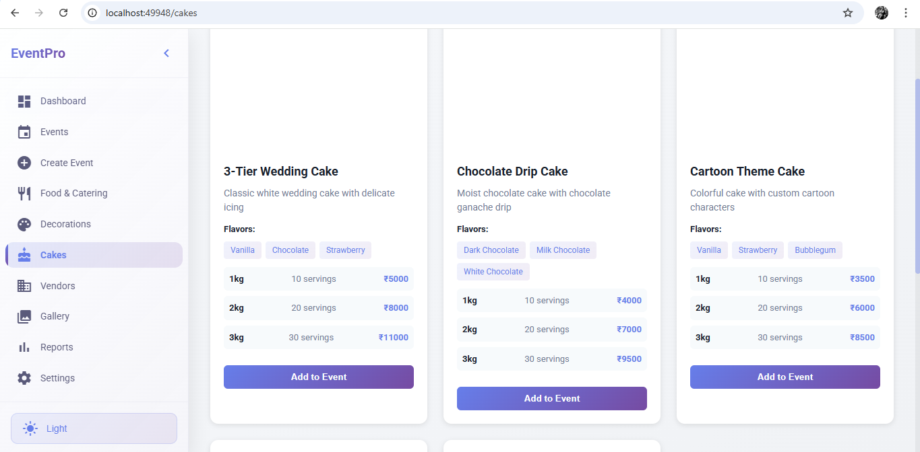

**Vendors Page**

**✅ How It Works:**

Vendors include:

* Catering
* Decoration
* Photography
* Music

Each vendor contains:

* Vendor name
* Vendor type
* Contact details
* Assigned events

User can assign vendors while creating events.

**🎯 Purpose:**

* Manage third-party service providers
* Organize event resources efficiently

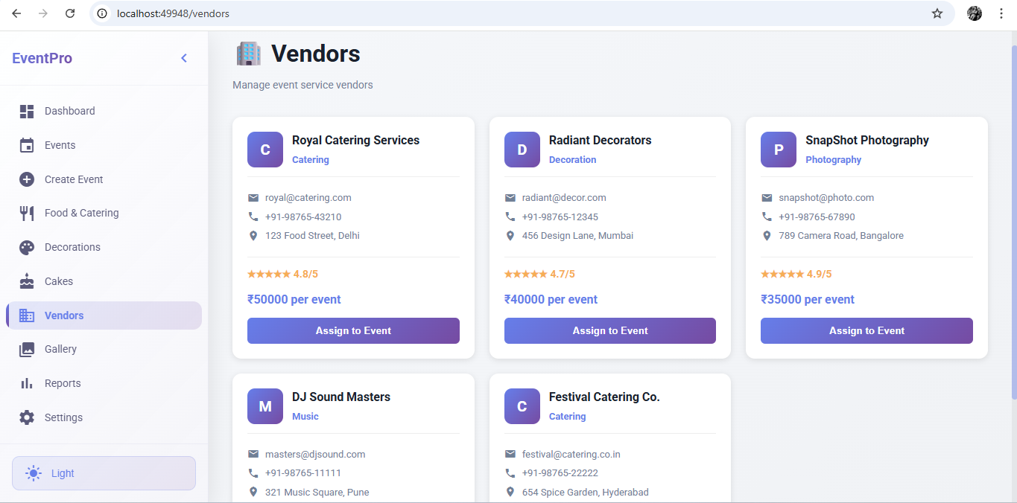

**Reports and Analytics :**

**✅ How It Works:**

This page shows analytics such as:

* Total Revenue
* Total Events
* Completed Events
* Most popular decoration
* Most selected food item

Charts are generated using Chart.js.

**🎯 Purpose:**

* Business performance tracking
* Revenue analysis
* Trend analysis

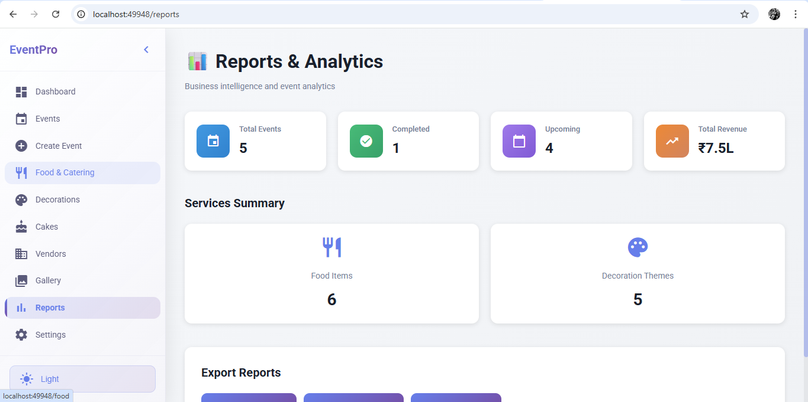

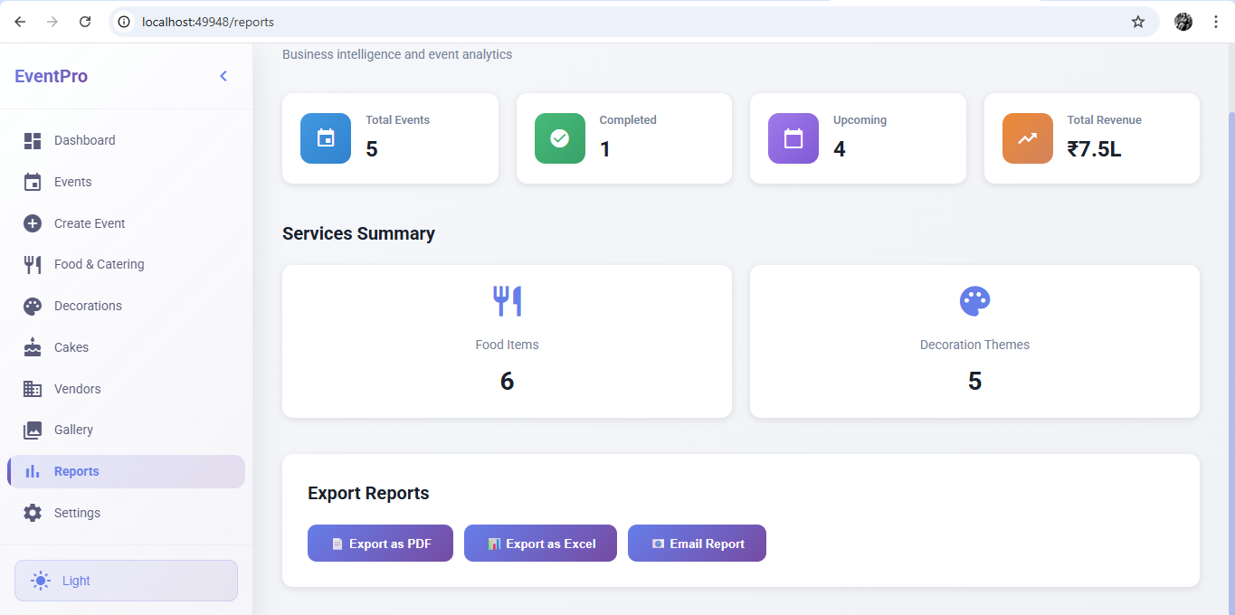

**1️⃣1️⃣ Settings Page**

**✅ How It Works:**

Settings allow:

* Dark/Light mode toggle
* Profile management
* Basic system configuration

**🎯 Purpose:**

* Personalize system
* Improve user experience

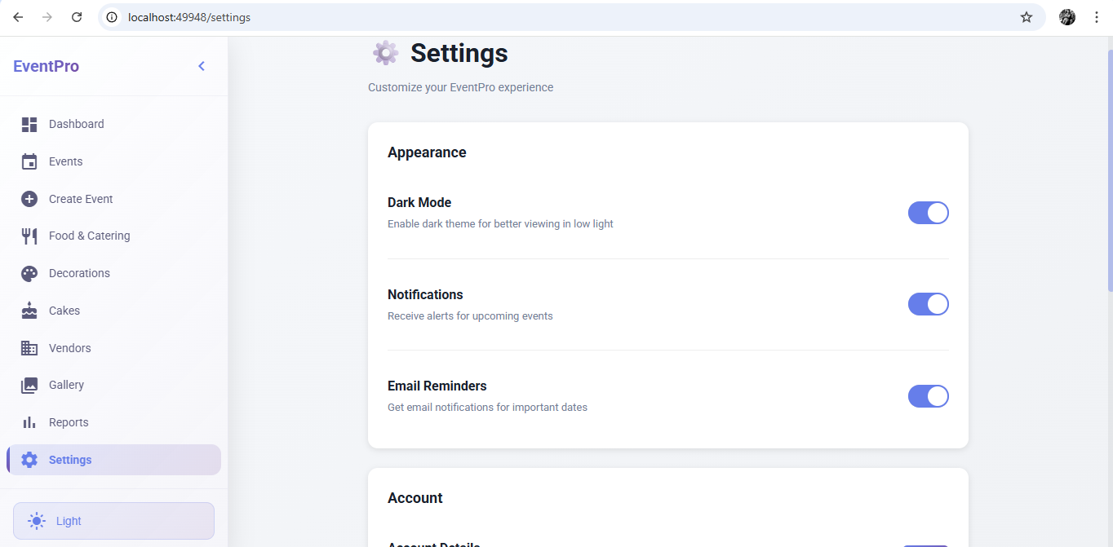

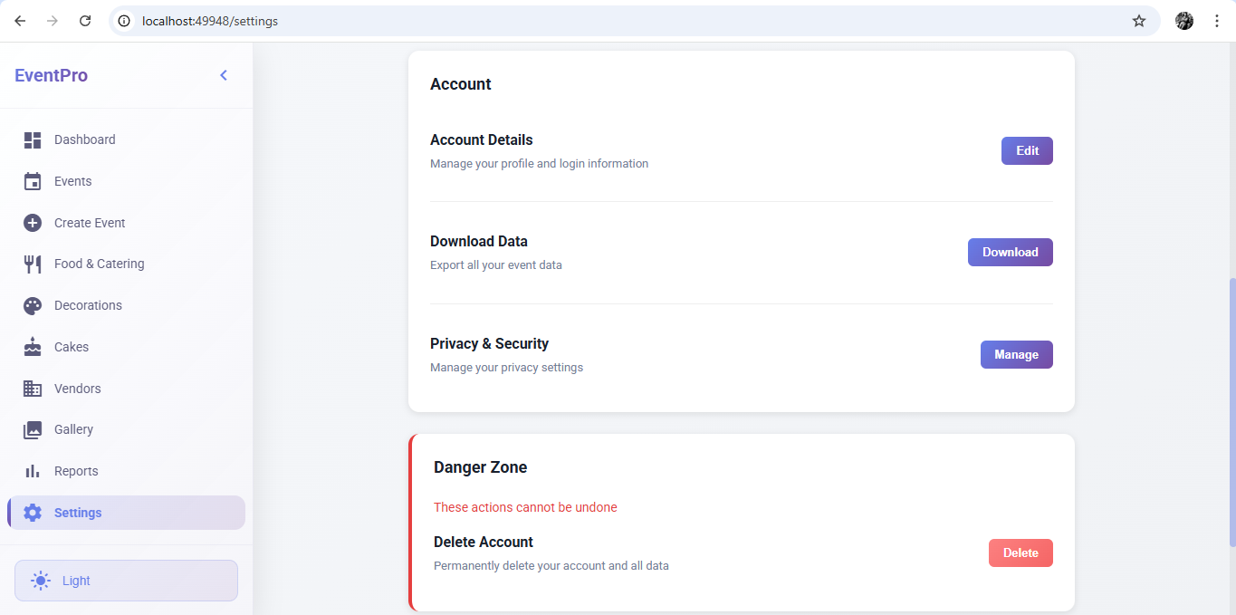

**What is Dark Theme?**

Dark Theme is a user interface mode where:

* Background colors are dark (black / dark blue / dark grey)
* Text is light (white / light grey)
* Cards use glass or shadow effects
* Accent colors (pink / purple / blue) stand out more

It improves visual comfort and gives a modern SaaS look.

**🎨 How Dark Theme Works in the Dashboard**

When Dark Mode is enabled:

* The background changes to a dark gradient.
* Dashboard statistic cards use glassmorphism effect.
* Text becomes light-colored for readability.
* Accent colors highlight important data.
* Charts use darker color palettes.
* Navbar and sidebar adapt to dark styling.

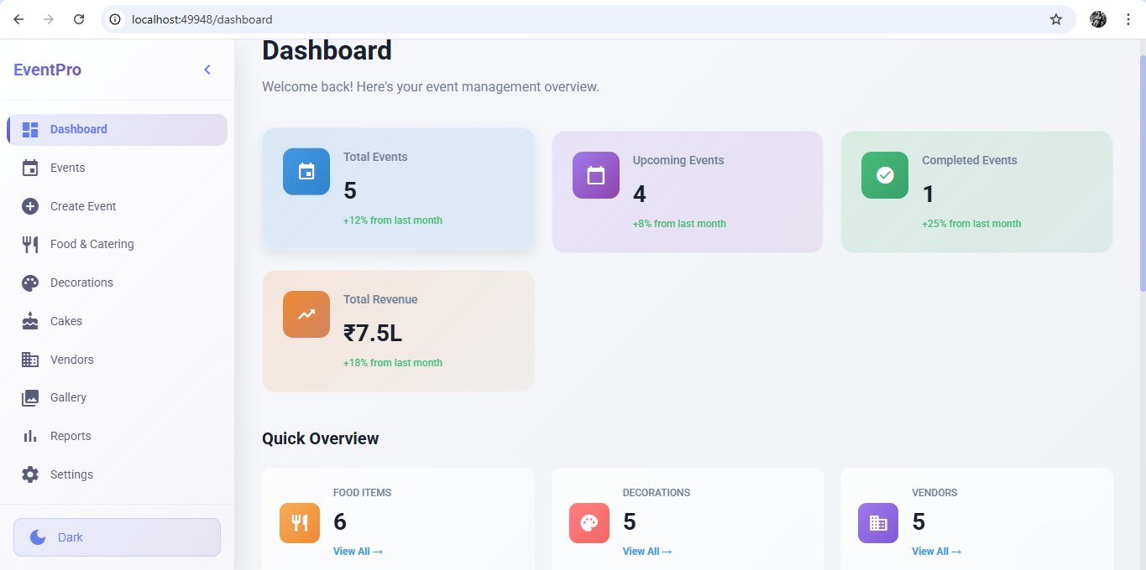

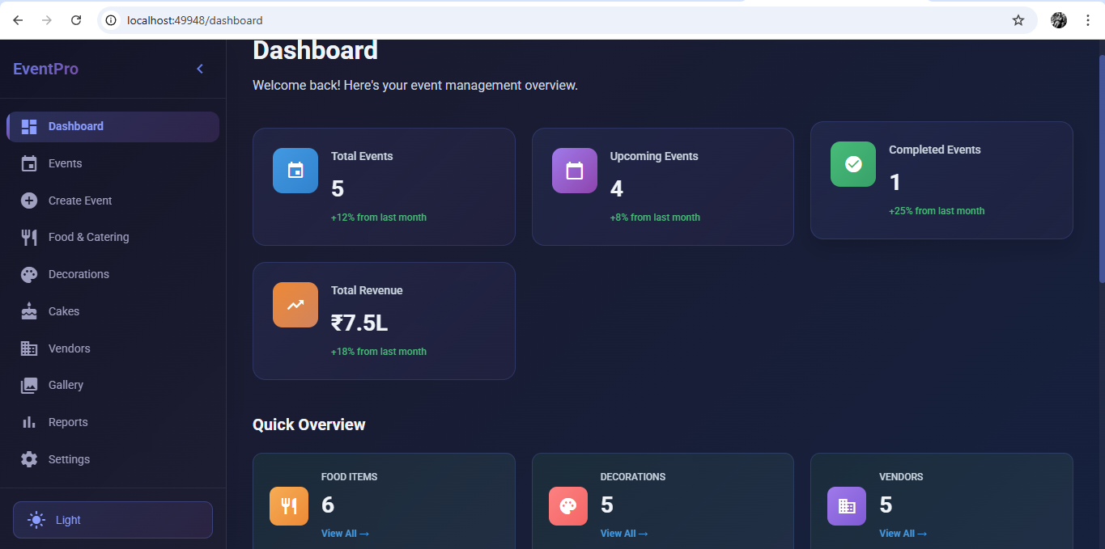

**🔄 Overall System Working Flow**

1. Admin creates event
2. Assigns client
3. Selects vendor
4. Adds food items
5. Chooses decoration theme
6. Selects cake
7. Budget auto-calculates
8. Event status updates
9. After completion → moves to gallery
10. Reports update automatically

**🧠 Technical Working Behind the Scenes**

* Angular Components handle UI
* Services manage data
* Routing handles page navigation
* Angular Material provides UI components
* Local storage / memory handles temporary data
* Chart.js handles analytics

**🏁 Conclusion**

This Event Management System provides:

✔ Complete event lifecycle management  
✔ Client & vendor tracking  
✔ Food & decoration customization  
✔ Budget calculation  
✔ Business analytics  
✔ Attractive modern UI